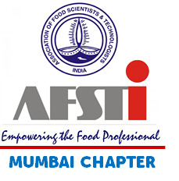 | Technical Seminar on Demystifying Regulatory Requirements  19th & 20th March 2019, Hotel Kohinoor Continental, Andheri-Kurla Road, J. B. Nagar, Andheri East, Mumbai - 400059

Seminar Registration Form to be sent to event.afst@gmail.com or

Hard copy along with check to:
AFST(I) Mumbai Chapter
C/O Head, Food Engineering and Technology Department
Institute of Chemical Technology (ICT)
Nathalal Parekh Marg, Matunga (E) Mumbai 400 019

Participant Details
Participant 1
Name of Participant
AFST(I) Membership Number
Name of Organization & Designation
E-Mail ID
Mobile Number
Participant 2
Name of Participant
AFST (I) Membership Number
Name of Organization & Designation
E-Mail ID
Mobile Number

Payment Details
NEFT / Cheque Number |  | Bank Name & Branch
Amount in INR |  | Date of payment

Bank Details for Payment
Account Name / Cheque in favour of | AFST (I) Mumbai Chapter
Bank Name | Bank of Maharashtra
Bank Address | Mahajani, Kings Circle, Mumbai
Account Number | 20019465071
IFSC CODE | MAHB0000339

AFST(I) Contact Details
Khushbu Haria, LEC Member | 81087 67849
Yogita Salunke, LEC Member | 91672 32026

